



**Investigating costs of using electrical appliances**

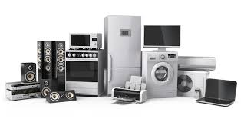

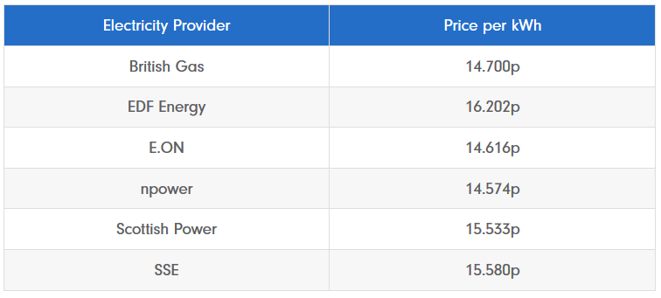

|  |  |  |  |  |  |  |
| --- | --- | --- | --- | --- | --- | --- |
| Appliance | Watts | Kilowatts | Average daily usage | Kilowatt Hours | Electricity Provider | Cost |
|  |  |  |  |  |  |  |
|  |  |  |  |  |  |  |
|  |  |  |  |  |  |  |
|  |  |  |  |  |  |  |
|  |  |  |  |  |  |  |
|  |  |  |  |  |  |  |
|  |  |  |  |  |  |  |