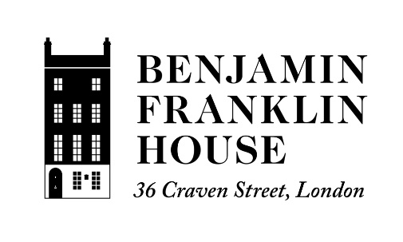

Online Safety Agreement:

- I will be responsible for my behaviour when using the internet, including social media platforms, games and apps. This includes the resources I access and the language I use

- I will not deliberately browse, download or upload material that could be considered offensive or illegal. If I accidentally come across any such material I will report it immediately to Benjamin Franklin House Education Manager.

- I will not send anyone material that could be considered threatening, bullying, offensive or illegal
.
- I will not give out any personal information online, such as my full name, phone number, address or passwords

- If I am concerned or upset about anything I see on the internet or any messages that I receive, I know I can talk to the Benjamin Franklin House Education Manager

- I understand that these rules are designed to keep me safe and that if I choose not to follow them, Benjamin Franklin House may contact my parents/carers

