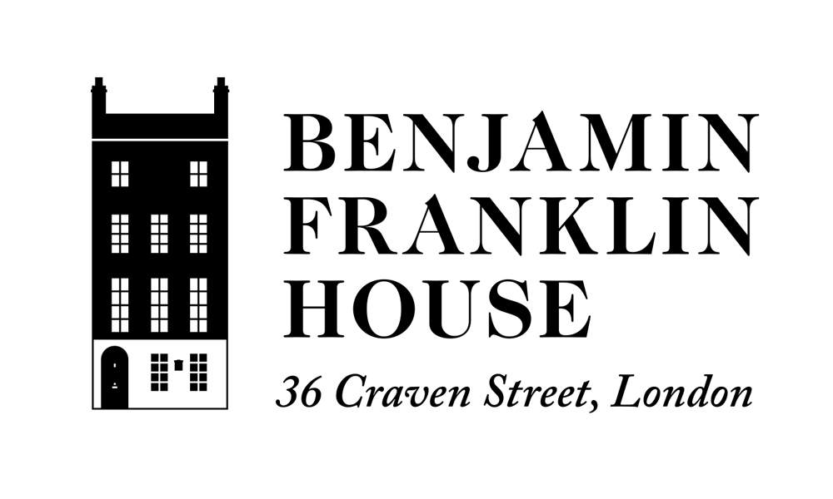

Educational Visit Booking Form

SCHOOL NAME

SCHOOL ADDRESS

POSTCODE BOROUGH

TELEPHONE

E-MAIL

NAME OF GROUP LEADER (TEACHER)

School Type
(Please tick one box)

□ Infant | □ Junior | □ Secondary
□ Special | □ Home Schooling | □ University

Do any members of your group have any special needs we should be aware of? If so, please detail here:

Preferred date and time of visit:
(A Level visits can be booked Wednesdays or Thursdays at 12pm, 1pm or 2pm)

NO. OF PUPILS VISITING KEY STAGE YEAR OF GROUP

NO. OF TEACHERS VISITING NO. OF ADULT HELPERS VISITING

How did you hear about educational visits at Benjamin Franklin House? (Please tick all appropriate)

□ Leaflet | □ Letter
□ Word of mouth | □ Previous visit to the House
□ Email | □ Other, please specify:

| RETURNING YOUR FORM |

Please send your completed form to the Education Manager who will contact you to discuss arrangements.

Contact our Education Manager at:
Benjamin Franklin House, 36 Craven Street, London WC2N 5NF
Telephone +44 (0) 207 839 2013
Email: education@benjaminfranklinhouse.org

